Packages are the container for the classes

They are just the folders

Rule : We can not create two java files with same name, inside one folder

So we create more than one folder and place our same .java file inside them

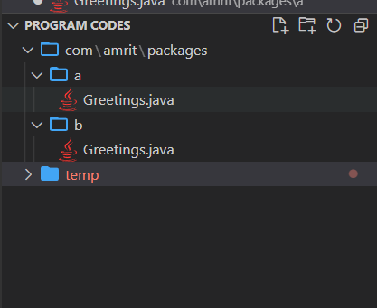

Here inside package folder there are two folders “a” and “b”

And inside both of them there is same .java file

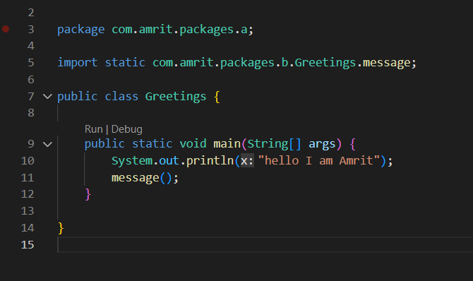

package can be specified at the beginning of the code like this

**Importance of packages**

**How to do import in java ?**

We can define various java files / classes in various folders / packages and then we can define one function in one file and call that and use that in another file

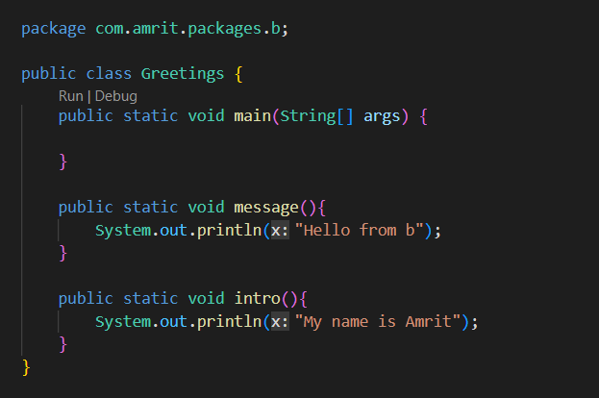

here we are defining message function in the java file present in the package 

And we are importing that function in the java file present in the package 

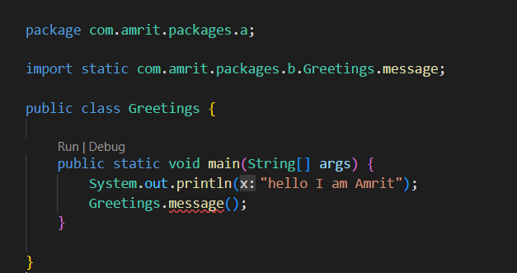

And we were able to call the function which is actually defined in java file in another package

this was possible becoz of import

Also if the classes or the .java files are in the same folder then it is not needed to import

Classes present inside the same package should not needed to be imported to use



here we have Human.java and main.java inside the same folder random

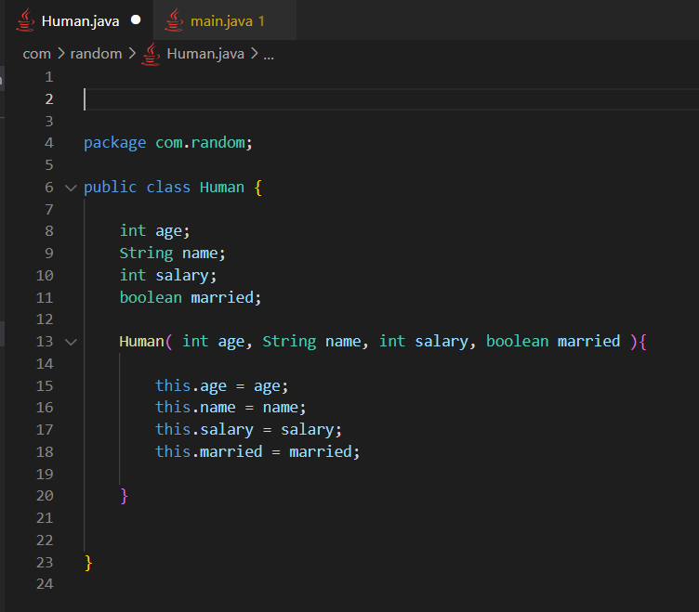

Human class is defined in the Human.java

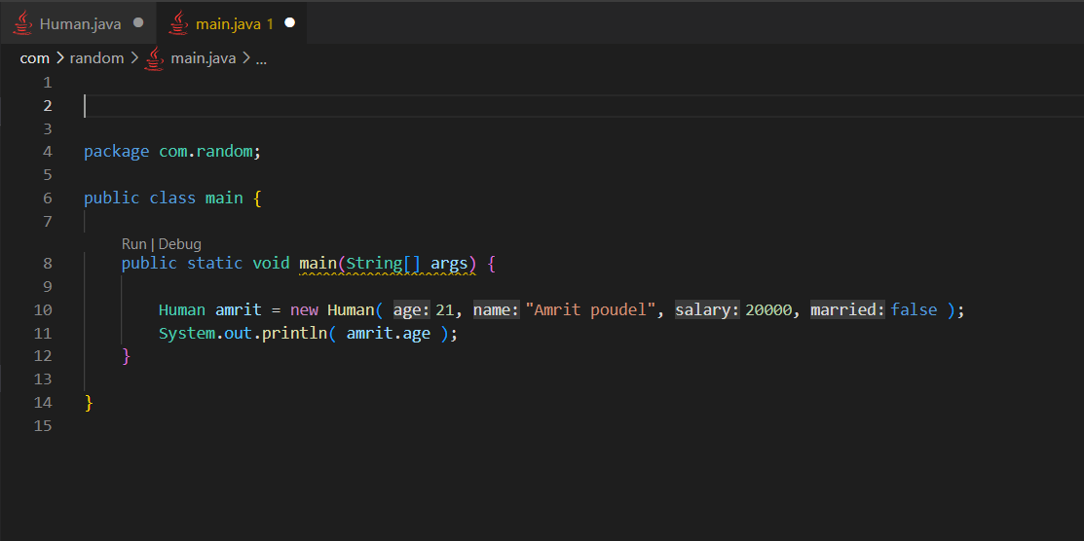

Here we were able to make the instance of the Human class without importing

Because both of the files lies in the same folder